***Organisation’s name* Equally Well action plan**

▶ Action 1

▶ Action 2

▶ Action 3

▶ Action 4

***Organisation name***

**EQUALLY WELL ACTION PLAN: *timeframe (in years)***

By endorsing the [consensus position paper](https://www.tepou.co.nz/resources/equally-well-consensus-position-paper), we acknowledge the physical health inequities in people who experience mental health and addiction issues; and we are committed to taking action to achieve physical health equity.  In particular, aligned with our commitment we believe that people with experience of addiction and mental health issues:

▶ be identified as a priority group at a national policy level based on significant health risks, poorer physical health outcomes and a higher prevalence of premature mortality

▶ have access to the same quality of care and treatment for physical health issues as the general population, and in particular to have the right to assessment, screening and monitoring for physical health and wellbeing that takes into account greater levels of risk

▶ be offered support to make the connection to how physical health interacts with mental health and addiction issues, and support to develop personal goals and changes to enhance physical wellbeing.

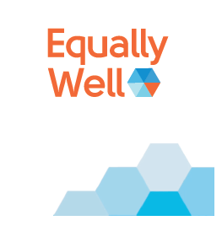

**These are the guiding principles of Equally Well**

**that we will adopt for implementation**